An Industry Oriented Mini Project Report On

### TYPING SPEED TEST

Submitted to **Jawaharlal Nehru Technological University** in partial fulfillment of the requirements for the award of degree of

### BACHELOR OF TECHNOLOGY

In

### Computer Science and Engineering

Submitted By

###### K Sowmya Reddy (18R05A0523)

**P Udaya Sree (17R01A05F5)**

**U Vikhitha Sindu (17R01A05H2)**

**A Shivani (17R01A05J1)**

Under the Guidance of

**Mr.K. Pradeep Reddy M.Tech.,(PhD)**

(Asst.professor, CSE)



**CMR INSTITUTE OF TECHNOLOGY**

**(UGC Autonomous)**

(Approved by AICTE, Affiliated to JNTU Hyderabad) Kandlakoya, Medchal Road, Hyderabad.

**2020-2021**

**CMR INSTITUTE OF TECHNOLOGY**

**(UGC Autonomous)**

(Approved by AICTE, Affiliated to JNTU Hyderabad) Kandlakoya, Medchal Road , Hyderabad.



**CERTIFICATE**

This is to certify that An Industry Oriented Mini Project "**TYPING SPEED TEST**" is being

Submitted By

###### K Sowmya Reddy (18R05A0523)

**P Udaya Sree (17R01A05F5)**

**U Vikhitha Sindu (17R01A05H2)**

**A Shivani (17R01A05J1)**

In partial fulfillment of the requirement for award of the degree of B.Tech in Computer Science and Engineering to the JNTU, Hyderabad is a record of a bonafide work carried out under our guidance and supervision.

The results in this project have been verified and are found to be satisfactory. The results embodied in this work have not been submitted to any other University for the award of any other degree or diploma.

|  |  |  |
| --- | --- | --- |
| **Signature of the Guide**  Mr.K. Pradeep Reddy | **Signature of Coordinator**  Mrs.G. Naga Rama Devi | **Signature of HOD**  Mr.A. Prakash |
| (Asst.Professor, CSE) | (Assoc.Professor, CSE) | (HOD, CSE) |

###### EXTERNAL EXAMINER

**ACKNOWLEDGEMENT**

We are extremely grateful to **Dr. M. Janga Reddy**, Director, **Dr. B. Satyanarayana,** Principal and **Dr. A. Prakash**, HOD, Department of CSE, CMR Institute of Technology for their inspiration and valuable guidance during entire course duration.

We are extremely grateful to **Mr. G. Naga Rama Devi**, Mini Project Coordinator and Internal Guide **Mr. K. Pradeep Reddy**, Department of CSE, for their constant guidance, encouragement and moral support throughout the project.

We will be failing in duty if I do not acknowledge with grateful thanks to the authors of the references and other literatures referred in this project.

We express our thanks to all staff members and friends for all the help and co-ordination extended in bringing out this project successfully in time.

Finally, we are very much thankful to our parents and relatives who guided directly or indirectly for every stage towards success.

###### K Sowmya Reddy (18R05A0523)

**P Udaya Sree (17R01A05F5)**

**U Vikhitha Sindu (17R01A05H2)**

**A Shivani (17R01A05J1)**

TYPING SPEED TEST

### ABSTRACT:

The Typing Speed In Python is a simple project for improving your Typing speed. The project contains only the user side. It is a simple typing challenge game mini-project. This is like a game, one-by-one random word will pop up on your screen and you have to type as many given words as you can. Typing games are a great way to learn the position of all the keys on the keyboard and also help you practice your typing while having fun. The project file contains python scripts. This app project just contains the user section. The player/user can improve their Typing speed playing this game. You have to type as many words as you can in the given amount of seconds to score. Otherwise, you will lose the game, and to play again, you just have to type the current word. Also, your score will be reset and the high score will be set on the game. The design of this project is pretty simple so that the user won’t find any difficulties while working on it.

### TABLE OF CONTENTS

1. INTRODUCTION 1
   1. SYSTEM STUDY **2**
2. SYSTEM ANALYSIS 3
   1. EXISTING SYSTEM **4**
   2. PROPOSED SYSTEM **4**
   3. ALGORITHM **5**
3. REQUIREMENT ANALYSIS 6
   1. SOFTWARE REQUIREMENTS **7**
   2. HARDWARE REQUIREMENTS **7**
4. SYSTEM DESIGN 8
   1. SYSTEM ARCHITECTURE **9**

**4.2** INPUT AND OUTPUT DESIGN **10**

**4.3** MODULES **12**

1. IMPLEMENTATON 13
   1. TECHNOLOGIES USED **14**
   2. SAMPLE CODE **15**
2. SCREENSHOTS 17
3. CONCLUSION 24

REFERENCES 26

**INTRODUCTION**

## 1.1 SYSTEM STUDY

**FEASIBILITY STUDY**

The feasibility of the project is analyzed in this phase and business proposal is put forth with a very general plan for the project and some cost estimates. During system analysis the feasibility study of the proposed system is to be carried out. This is to ensure that the proposed system is not a burden to the company. For feasibility analysis, some understanding of the major requirements for the system is essential.

###### Three key considerations involved in the feasibility analysis are

* **ECONOMICAL FEASIBILITY**
* **TECHNICAL FEASIBILITY**
* **SOCIAL FEASIBILITY**

**ECONOMIC FEASIBILITY**

This study is carried out to check the economic impact that the system will have on the organization. The amount of fund that the company can pour into the research and development of the system is limited. The expenditures must be justified. Thus the developed system as well within the budget and this was achieved because most of the technologies used are freely available. Only the customized products had to be purchased.

###### TECHNICAL FEASIBILITY

This study is carried out to check the technical feasibility, that is, the technical requirements of the system. Any system developed must not have a high demand on the available technical resources. This will lead to high demands on the available technical resources. This will lead to high demands being placed on the client. The developed system must have a modest requirement, as only minimal or null changes are required for implementing this system.

###### SOCIAL FEASIBILITY

The aspect of study is to check the level of acceptance of the system by the user. This includes the process of training the user to use the system efficiently. The user must not feel threatened by the system, instead must accept it as a necessity. The level of acceptance by the users solely depends on the methods that are employed to educate the user about the system and to make him familiar with it. His level of confidence must be raised so that he is also able to make some constructive criticism, which is welcomed, as he is the final user of the system.

# SYSTEM ANALYSIS

### EXISTING SYSTEM:

In the market most of the typing speed test tools are build in Java. We know how robust Java code is and also upon research we found out that the speed testing tools built in java are not as accurate. The disadvantage of having the code is the complexity of java and also the efficiency when compared to the python model. So, our proposal is to build this project in python which is more accurate and efficient.

###### PROPOSED SYSTEM:

In this python project, it is user- friendly, efficient and accurate than java code and you will figure out how to make a speed typing test using python. It's an extremely helpful project to keep track of your typing speed and improve it with regular practice. This mini python project is very interesting, simple and best for practice purposes. Speed Typing Test is a python based project that will check your typing speed in wpm (word per minute), accuracy, correct & wrong words, most missed words, most inaccurate words, etc. This can be useful and helpful for those people who are not good at typing, they can do this test and get to know where they need to improve.

###### 2.3 ALGORITHM:

To start with, we are utilizing the pygame library. So we have to import the library alongside some inherent modules of Python like time and irregular libraries. Presently, we make the game class which will include numerous functions responsible for beginning the game, reset the game and few helper functions to perform calculations that are required for our project.

### 2.3.1 IMPORT THE LIBRARIES

For this project based on Python, we are using the pygame library. So we need to import the library along with some built-in modules of Python like time and random library.

### 2.3.2 CREATE THE GAME CLASS

Now we create the game class which will involve many functions responsible for starting the game, reset the game and few helper functions to perform calculations that are required for our project in Python.

**2.3.3 CHECK_RESULT() METHOD**

The check_results() method is where we **calculate the speed** of the user’s typing. The time starts when the user clicks on the input box and when the user hits return key “Enter” then we perform the difference and calculate time in seconds. To calculate accuracy, we did a little bit of math. We counted the correct typed characters by comparing input text with the display text which the user had to type.

# REQUIREMENT ANALYSIS

##### REQUIREMENT ANALYSIS

The project involved analyzing the design of few applications so as to make the application more users friendly. To do so, it was really important to keep the navigations from one screen to the other well-ordered and at the same time reducing the amount of typing the user needs to do. In order to make the application more accessible, the browser version had to be chosen so that it is compatible with most of the Browsers.

###### REQUIREMENT SPECIFICATION

**Functional Requirements**

* Graphical User interface with the User.

###### Software Requirements

For developing the application the following are the Software Requirements:

1. Python
2. IDLE (Python 3.9 64-bit)
3. Python 3.9 (64-bit)
4. Command Prompt

###### Operating Systems supported

1. Windows 7
2. Windows XP
3. Windows 8

###### Technologies and Languages used to Develop

1. Python

###### Debugger and Emulator

* Any Browser (Particularly Google Chrome)

###### Hardware Requirements

For developing the application the following are the Hardware Requirements:

* Processor : Pentium IV or higher
* RAM : 256 MB
* Space on Hard Disk : Minimum 512MB

# SYSTEM DESIGN

### SYSTEM ARCHITECTURE

*Fig: System Architecture*

### INPUT AND OUTPUT DESIGN

* + 1. **INPUT DESIGN**

The input design is the link between the information system and the user. It comprises the developing specification and procedures for data preparation and those steps are necessary to put transaction data in to a usable form for processing can be achieved by inspecting the computer to read data from a written or printed document or it can occur by having people keying the data directly into the system. The design of input focuses on controlling the amount of input required, controlling the errors, avoiding delay, avoiding extra steps and keeping the process simple. The input is designed in such a way so that it provides security and ease of use with retaining the privacy. Input Design considered the following things:

* What data should be given as input?
* How the data should be arranged or coded?
* The dialog to guide the operating personnel in providing input.
* Methods for preparing input validations and steps to follow when error occur.

### OBJECTIVES

* + - 1. Input Design is the process of converting a user-oriented description of the input into a computer-based system. This design is important to avoid errors in the data input process and show the correct direction to the management for getting correct information from the computerized system.
      2. It is achieved by creating user-friendly screens for the data entry to handle large volume of data. The goal of designing input is to make data entry easier and to be free from errors. The data entry screen is designed in such a way that all the data manipulates can be performed. It also provides record viewing facilities.
      3. When the data is entered it will check for its validity. Data can be entered with the help of screens. Appropriate messages are provided as when needed so that the user will not be in maize of instant. Thus the objective of input design is to create an input layout that is easy to follow.

### OUTPUT DESIGN

A quality output is one, which meets the requirements of the end user and presents the information clearly. In any system results of processing are communicated to the users and to other system through outputs. In output design it is determined how the information is to be displaced for immediate need and also the hard copy output. It is the most important and direct source information to the user. Efficient and intelligent output design improves the system’s relationship to help user decision-making.

* + - 1. Designing computer output should proceed in an organized, well thought out manner; the right output must be developed while ensuring that each output element is designed so that people will find the system can use easily and effectively. When analysis design computer output, they should Identify the specific output that is needed to meet the requirements.
      2. Select methods for presenting information.
      3. Create document, report, or other formats that contain information produced by the system.

The output form of an information system should accomplish one or more of the following objectives.

* Convey information about past activities, current status or projections of the
* Future.
* Signal important events, opportunities, problems, or warnings.
* Trigger an action.
* Confirm an action.

### MODULES:

###### PyGame:

Pygame library is an open-source module for the Python programming language explicitly proposed to assist you with making games and other mixed media applications. Based on the profoundly versatile SDL (Simple Direct Media Layer) improvement library, pygame can stumble into numerous stages and working frameworks. Pygame is a cross platform set of Python modules designed for writing video games. Pygame adds functionality on top of the excellent SDL(simple direct media layer) library. This allows you to create fully featured games and multimedia programs in the python language. Pygame is highly portable and runs on nearly every platform and operating system. It consists of computer graphics and sound libraries designed to be used with the Python programming language.

###### Pytest-Timeit:

The pytest framework makes it easy to write small tests, yet scales to support complex functional testing for applications and libraries. Pytest is a testing framework which allows us to write test codes using python. You can write code to test anything like database , API, even UI if you want. But pytest is mainly being used in industry to write tests for APIs.pytest is very simple to start because it uses simple syntax, it can run the tests in parallel, and also it is a open source.

Timeit module that is meant to measure the execution times of small and large code snippets. This module provides a simple way to measure small bits of Python code. It has both a Command-Line Interface as well as a callable one. The Python library runs the code statement 1 million times and provides the minimum time taken from the given set of code snippets.

###### Tkinter

###### The tkinter package (Tk interface) is the standard Python interface to the Tk GUI toolkit. Both Tk and tkinter are available on most Unix platforms, as well as on Windows systems.Tkinter is the standard GUI library for Python. Python when combined with Tkinter provides a fast and easy way to create GUI applications. Tkinter provides a powerful object-oriented interface to the Tk GUI toolkit.Tkinter provides various controls, such as buttons, labels and text boxes used in a GUI application. These controls are commonly called widgets.

# IMPLEMENTATION

## TECHNOLOGIES USED

### PYTHON

Python is a general-purpose interpreted, interactive, object-oriented, and high-level programming language. An [interpreted language](https://en.wikipedia.org/wiki/Interpreted_language), Python has a design philosophy that emphasizes code [readability](https://en.wikipedia.org/wiki/Readability) (notably using [whitespace](https://en.wikipedia.org/wiki/Whitespace_character) indentation to delimit [code blocks](https://en.wikipedia.org/wiki/Code_block) rather than curly brackets or keywords), and a syntax that allows programmers to express concepts in fewer [lines of](https://en.wikipedia.org/wiki/Source_lines_of_code) [code](https://en.wikipedia.org/wiki/Source_lines_of_code) than might be used in languages such as [C++](https://en.wikipedia.org/wiki/C%2B%2B) or [Java](https://en.wikipedia.org/wiki/Java_(programming_language)). It provides constructs that enable clear programming on both small and large scales. Python interpreters are available for many [operating](https://en.wikipedia.org/wiki/Operating_system) [systems.](https://en.wikipedia.org/wiki/Operating_system) [CPython,](https://en.wikipedia.org/wiki/CPython) the [reference implementation](https://en.wikipedia.org/wiki/Reference_implementation) of Python, is [open source](https://en.wikipedia.org/wiki/Open_source) software and has a community based development model, as do nearly all of its variant implementations. CPython is managed by the non-profit [Python Software Foundation](https://en.wikipedia.org/wiki/Python_Software_Foundation). Python features a [dynamic type](https://en.wikipedia.org/wiki/Dynamic_type) system and automatic [memory management](https://en.wikipedia.org/wiki/Memory_management). It supports multiple [programming paradigms,](https://en.wikipedia.org/wiki/Programming_paradigm) including [object-oriented](https://en.wikipedia.org/wiki/Object-oriented_programming), [imperative,](https://en.wikipedia.org/wiki/Imperative_programming) [functional](https://en.wikipedia.org/wiki/Functional_programming) and [procedural,](https://en.wikipedia.org/wiki/Procedural_programming) and has a large and comprehensive [standard library.](https://en.wikipedia.org/wiki/Standard_library)

## SAMPLE CODE

### */Typing Speed Test/*

from tkinter import *

from timeit import default_timer as timer

import random

window = Tk()

window.geometry("450x200")

x = 0

def game():

global x

if x == 0:

window.destroy()

x = x+1

def check_result():

if entry.get() == words[word]:

end = timer()

print(end-start)

else:

print("Wrong Input")

words = ['programming', 'coding', 'algorithm',

'systems', 'python', 'software']

word = random.randint(0, (len(words)-1))

start = timer()

windows = Tk()

windows.geometry("450x200")

x2 = Label(windows, text=words[word], font="times 20")

x2.place(x=150, y=10)

x3 = Label(windows, text="Start Typing", font="times 20")

x3.place(x=10, y=50)

entry = Entry(windows)

entry.place(x=280, y=55)

b2 = Button(windows, text="Done",

command=check_result, width=12, bg='grey')

b2.place(x=150, y=100)

b3 = Button(windows, text="Try Again",

command=game, width=12, bg='grey')

b3.place(x=250, y=100)

windows.mainloop()

x1 = Label(window, text="Lets start playing..", font="times 20")

x1.place(x=10, y=50)

b1 = Button(window, text="Go", command=game, width=12, bg='grey')

b1.place(x=150, y=100)

window.mainloop()

# SCREENSHOTS

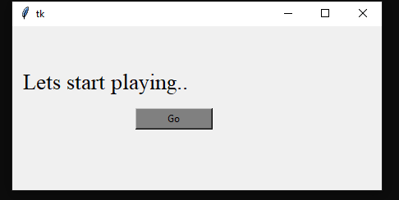

*Fig (7.01)*

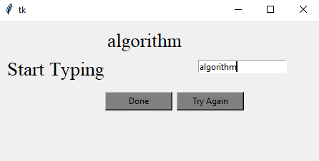

*Fig (7.02)*

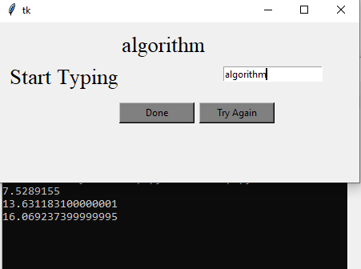

*Fig (7.03)*

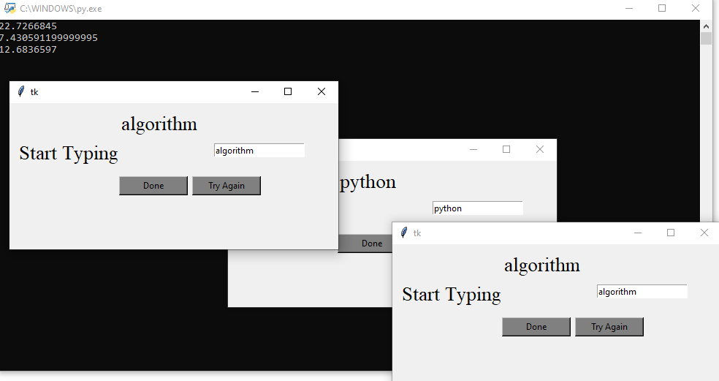

*Fig (7.04)*

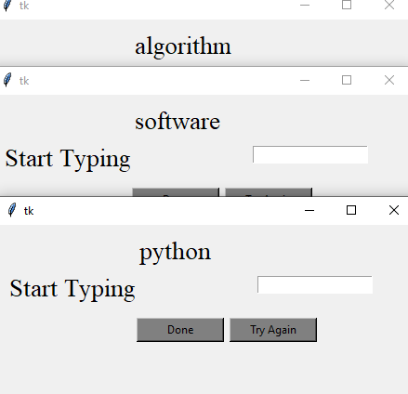

*Fig (7.05)*

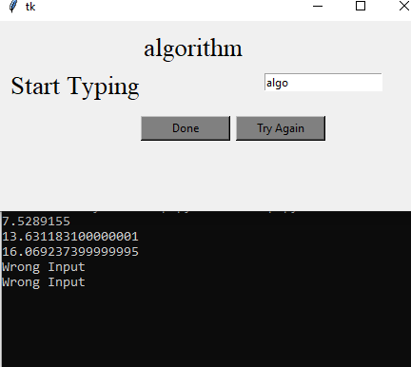

*Fig (7.06)*

# CONCLUSION

### CONCLUSION:

Learning to improve the speed in typing speed test takes time as it is a skill to be practiced. Then, practicing the technique should be done on a regular basis. You will save your time and money by learning how to generate your typing speed. Practice is the most important factor that has to be installed in your mindset to achieve speed test. Through this small game we can able to check our typing skills because, it is must and important in our jobs world now-a-days. When you practice this game on daily basis, then we can improve our typing skills as well as it is fun playing a game by learning something which is helpful.

# 

# REFERENCES

### Reference:

1. <https://techvidvan.com/tutorials/project-in-python-typing-speed-test/>

2. https://www.typingtest.com/